**SYNOPSIS**

Pulse Oximetry is a test used to measure the oxygen level i.e., oxygen saturation of the blood. It is an easy, painless measure of how well oxygen is being sent to parts of your body furthest from your heart, such as the arms and legs.

The **MAX30100 sensor** is a **Pulse Oximetry** and **Heart Rate Monitor** which is used to check the health of a person with any condition that affects blood oxygen levels, such as:

* Heart Attack
* Heart Failure
* Lungs Cancer
* Asthma, etc.

No doubt the **Max30100 Pulse Oximeter**is an amazing sensor, still it has some disadvantages it may generate incorrect readings if the finger is not properly placed. The ambient light falling on the sensor can affect the final reading. While using the Max30100 Oximeter, make sure your finger is not moving because it can result in an incorrect reading.

One more thing that you really need to take care of while using the Max30100 Sensor is that, never press the sensor too hard as this affects the blood flow and as a result you will get incorrect readings. Try to place your finger softly and make sure your finger does not move, this way you can get the most accurate reading.

**MOTIVATION**

In the current COVID-19 scenario, many people with COVID-19 have low levels of oxygen in their blood, even when they feel well. Low oxygen levels can be an early warning sign that medical care is needed. If someone has COVID-19, a pulse oximeter may help them keep watch over their health and to know if they need medical care.

**WORKING OF OXYMETER**

* **OXYGEN SATURATION**

Pulse Oximeter measure oxygen saturation. Before we learn the principles of how pulse Oximeter work, we need to have an understanding of what oxygen saturation is. Oxygen enters the lungs and then is passed on into blood. The blood carries the oxygen to the various organs in our body. The main way oxygen is carried in our blood is by means of hemoglobin. The hemoglobin without oxygen we will call de oxygenated hemoglobin (deoxy Hb). The hemoglobin with oxygen, we will call oxygenated hemoglobin (oxy Hb).

Image

Oxygen saturation simply refers to the percentage of the available hemoglobin that carries oxygen. Take the situations below. There are 16 hemoglobin units and none of the 16 have oxygen. The oxygen saturation is therefore 0%.

Image

And if it carries 75% Oxygen

Image

And if all the blood cells carry the oxygen, then of course it is going to be 100%.

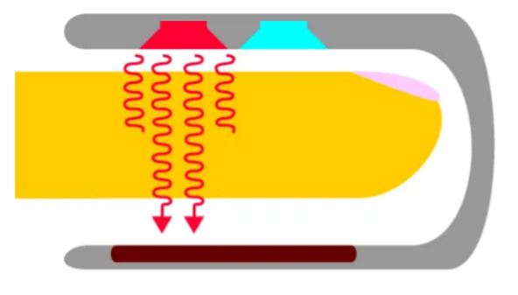

Image

Small beams of light pass through the blood in the finger, measuring the amount of oxygen. It does this by measuring changes in light absorption in oxygenated or deoxygenated blood.

The Oximeters come in different shapes and sizes, but the overall working principle of the pulse Oximeters is exactly the same. Some are of the clip type like the one you can see in the picture above, while some works on the reflection technique, as the one we are going to make works on the reflection. So, when the light passes or reflects, we can measure the Oxygen concentration.

**PROJECT DESCRIPTION**

In this project we will make a device that can measure Blood Oxygen & Heart Rate using MAX30100 Pulse Oximeter & Arduino. The blood Oxygen Concentration termed as SpO2 is measured in Percentage and Heart Beat/Pulse Rate is measured in BPM. The MAX30100 is a Pulse Oximetry and heart rate monitor sensor solution. We can also use MAX30102 which is an upgraded version of MAX30100.

We will display the SpO2 and BPM value in 0.96″ OLED Display. With each beat, the display value is changed in the OLED screen. By using Bluetooth module HC-05/HC-06 (operating in a slave mode), we can send data to the android app wirelessly and monitor the data on the app as well as keep a track record of the data in text format. In this way, we can send the data read from the device to another device or to the Internet.

* **MAX30100 PULSE OXIMETER SENSOR**

Image

The sensor is an integrated pulse oximetry and heart-rate monitor sensor solution. It combines two LED’s, a photo detector, optimized optics, and low-noise analog signal processing to detect pulse and heart-rate signals. It operates from 1.8V and 3.3V power supplies and can be powered down through software with negligible standby current, permitting the power supply to remain connected at all times.

**Features:**

1. Consumes very low power (operates from 1.8V and 3.3V).
2. Ultra-Low Shutdown Current (0.7 uA, typ)
3. Fast Data Output Capability

**Working of max30100 pulse oximeter and heart-rate sensor**

The device has two LEDs, one emitting red light, another emitting infrared light. For pulse rate, only the infrared light is needed. Both the red light and infrared light is used to measure oxygen levels in the blood.

When the heart pumps blood, there is an increase in oxygenated blood as a result of having more blood. As the heart relaxes, the volume of oxygenated blood also decreases. By knowing the time between the increase and decrease of oxygenated blood, the pulse rate is determined.

It turns out, oxygenated blood absorbs more infrared light and passes more red light while deoxygenated blood absorbs red light and passes more infrared light. This is the main function of the MAX30100: it reads the absorption levels for both light sources and stored them in a buffer that can be read via I2C.

* Hc-05 Bluetooth module

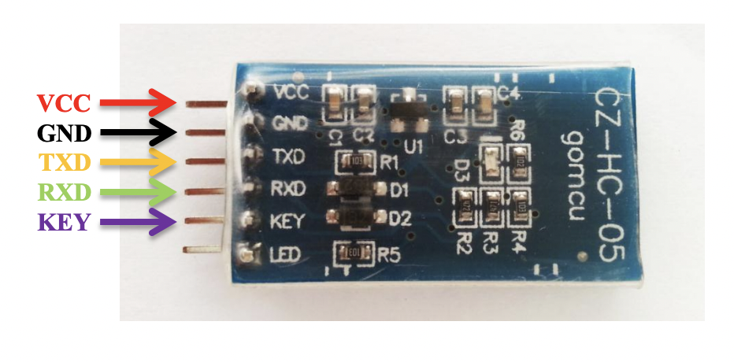

HC-05 Bluetooth Module is an easy-to-use Bluetooth SPP (Serial Port Protocol) module, designed for transparent wireless serial connection setup. Its communication is via serial communication which makes an easy way to interface with controller or PC. HC-05 Bluetooth module provides switching mode between master and slave mode which means it able to use neither receiving nor transmitting data.

* 0.96” I2C Oled display

Image

OLED (Organic Light-Emitting Diode) is a self light-emitting technology composed of a thin, multi-layered organic film placed between an anode and cathode. In contrast to LCD technology, OLED does not require a backlight. OLED possesses high application potential for virtually all types of displays and is regarded as the ultimate technology for the next generation of flat-panel displays.

0.96-inch OLED Display Module is a precise small, White OLED module which can be interfaced with any microcontroller using SPI protocol. It is having a resolution of 128x64. The package includes display board, display, 6 pin male header.

**CIRCUIT DIAGRAMS**

The circuit diagram & connection for interfacing MAX30100 Pulse Oximeter with Arduino along with HC-05 Bluetooth Module & OLED Display is given below.

Image

MAX30100 & OLED Display works on I2C Communication Protocol. So, its SDA & SCL pin is connected to I2C pin of Arduino, i.e. A4 & A5. Similarly, Bluetooth module is an UART module and need to be connected to Tx & Rx pins of Arduino.

**BLOCK DIAGRAMS**

Image

Image

**FLOWCHARTS**

Image

Image

**PCB DESIGN FOR PORTABLE PULSE OXIMETER**

Image

gantt chart

